PART A

1.

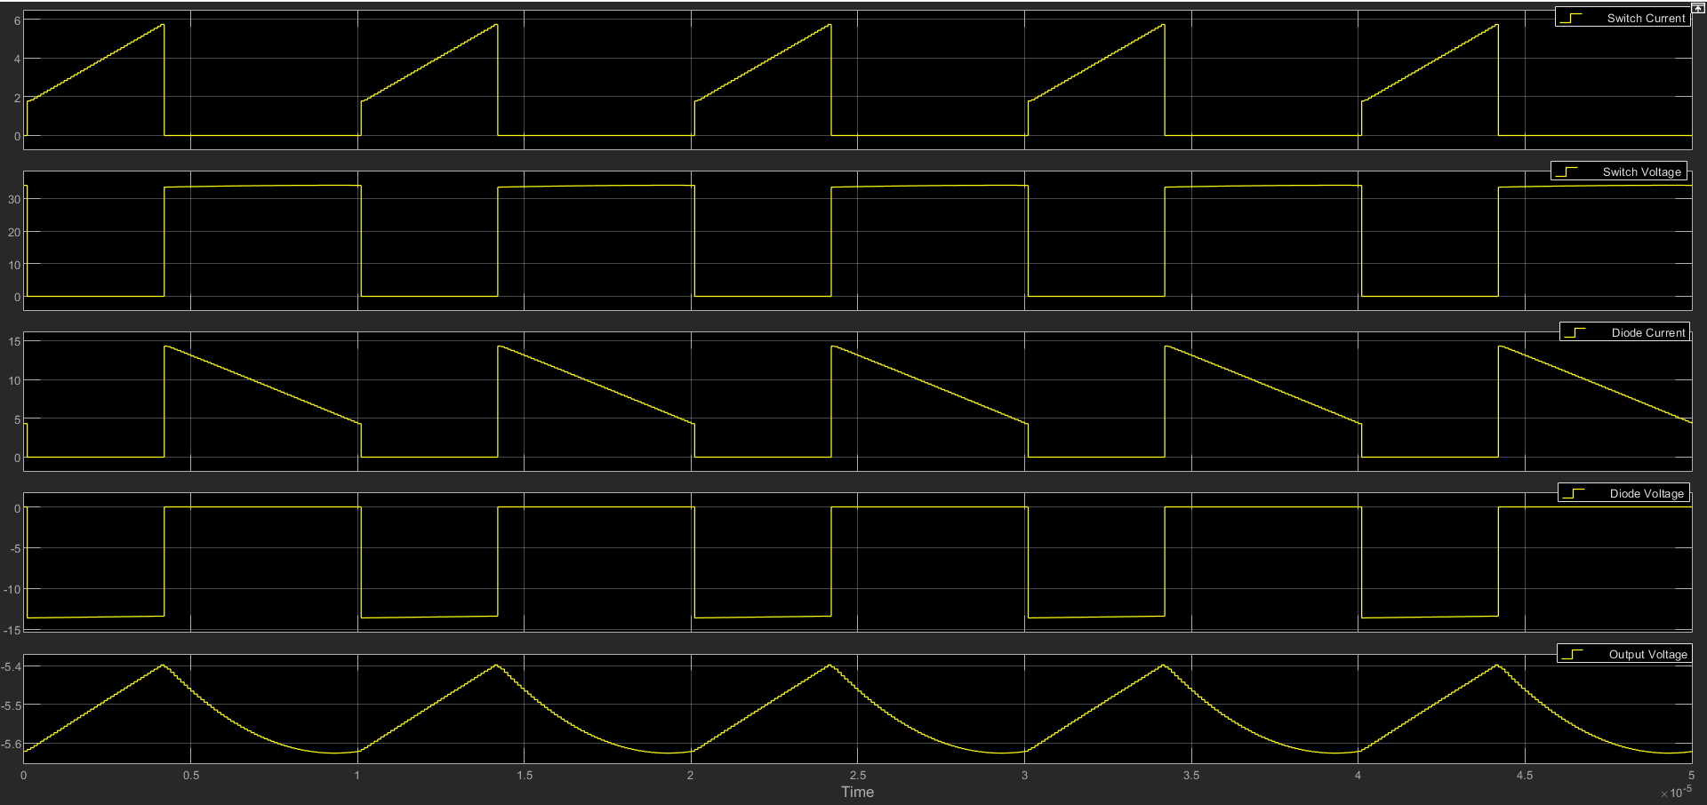

4.

|  |  |
| --- | --- |
| R | Vout |
| 1 | -7.85 |
| 1.5 | -7.826 |
| 2 | -7.826 |
| 2.5 | -8.526 |
| 3 | -9.57 |
| 3.5 | -10.35 |

PART B

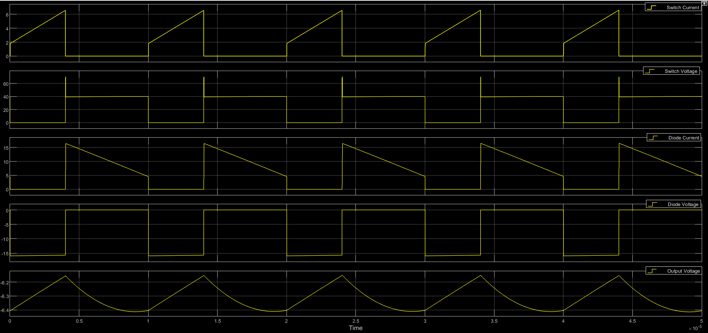

average voltage across the snubber capacitorCd = 18.64V

Calculate the power dissipated in the snubber resistorRd. = 0.50W